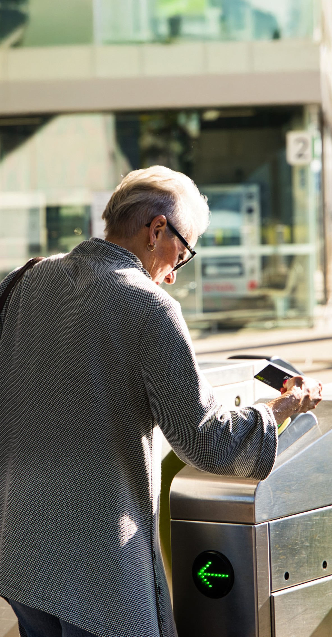

Customer
Compensation Code

Customer Compensation Code
At Metro, we closely monitor the performance of our train services.
We are committed to ensuring our train service is reliable and we work closely with the Government and Public Transport Victoria to not only meet our customer service and performance targets, but exceed them.
Our partnership with the Victorian Government emphasises the importance of delivering services in line with the agreed timetable. While we endeavour at all times to meet and exceed all our performance targets, on occasion circumstances may mean we fall short.
The performance targets relate to:
- Punctuality, measured as 92 per cent of services arriving on time at a destination. Train services are deemed as being on time if they are delivered between 59 seconds early, and 4 minutes and 59 seconds late.
- Reliability, measured as 98.5 per cent of the timetabled train services run.
Compensation is assessed for each calendar month.
Around the 10th day of each month we publish our monthly network-wide performance data on our website and at stations. We also advise customers of their eligibility for compensation at this time.
PTV publishes daily, monthly and quarterly reports on its website. These reports provide information about each public transport operator’s performance. You can access this report at ptv.vic.gov.au.
1
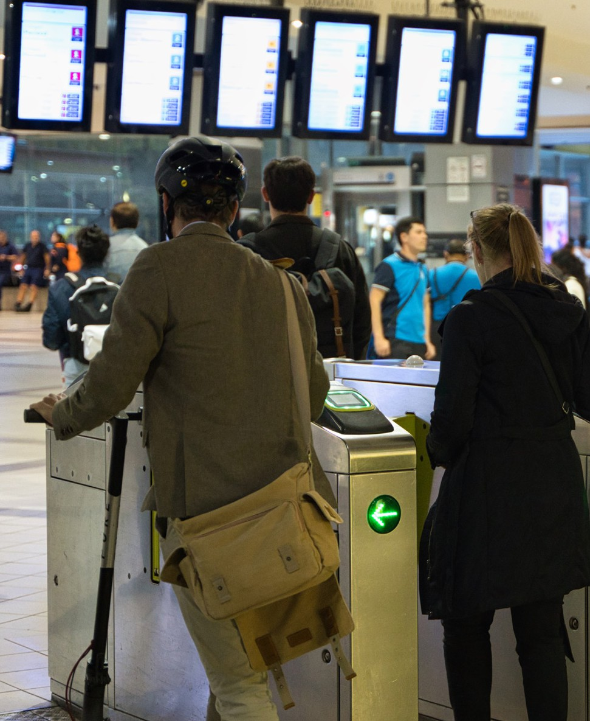
What are Metro’s compensation
thresholds?
Metro seeks to not only meet but exceed its performance targets. If this does not occur, eligible passengers can request compensation if performance falls below either or both of the following thresholds.
Metro’s compensation thresholds are:
- 90 per cent of trains run within 4 minutes 59 seconds of their published time schedule; or
- 98 per cent of the timetable is delivered.
2
Who is eligible for compensation?
The following table provides guidance for claiming compensation.
Description
myki
Customer eligibility
Holders of myki passes (Valid for 28 days or more) or myki Money can claim
Validity of claim
myki must have been touched on at least 10 days of the month on the metropolitan train network
Nature of compensation
The value of a daily ticket (or other value as defined) to be uploaded onto the customer’s myki. The value loaded will reflect the same fare/zone mix
as the myki Pass/myki Money being compensated
Applying for compensation
Submit an online compensation form at metrotrains.com.au; or see a staff member at any Metro Premium
station to request a printed Customer Compensation Code brochure.
Complete the form on the back and return by mail
Application deadline
The calendar month in which the results are notified
3

When is compensation paid?
myki compensation
value
Compensation trigger
Customer eligibility
If Metro delivers less than 98 per cent of its scheduled services in a calendar month
1 daily myki Money fare
If Metro delivers less than 95 per cent of its scheduled services in a calendar month
2 daily myki Money fares
Punctuality
If less than 90 per cent of Metro services are on time in a calendar month
1 daily myki Money fare
If less than 86 per cent of Metro services are on time in a calendar month
2 daily myki Money fares
4

Other Metro service commitments
We will also provide complimentary tickets to eligible customers who have experienced major inconvenience during their journey with us.
Metro makes the following commitments to our customers:
The following customers will receive a myki credit for the applicable zones, if a particular advertised train service is cancelled more than three times in a week and not replaced by a bus: weekly and periodical myki holders who touched on their myki within a half hour of these services on each of the relevant days.
If train services on a line are suspended for a period of over two hours and a bus replacement service
is not provided, all eligible myki holders who used the line on that day will receive a myki credit for the applicable zones.
Concession fare claimants will be compensated with myki credit to the value of the applicable fare.
1
2
3
To lodge a claim for any of the above circumstances, eligible customers can either submit their request online or by calling PTV Customer Service team on 1800 800 007 (6am to midnight daily, and all night Friday and Saturday). For online claims complete the Customer Feedback form accessed on the Contact Us page of metrotrains.com.au.
Our service commitments are outlined in more detail in our Customer Service Charter available at metrotrains.com.au.
5
Contact information
Metro
For metropolitan train information.
Call
1800 800 007 (6am – midnight daily)
TTY
(03) 9619 2727
Mail
Passenger Feedback, Metro Trains Melbourne GPO Box 1880, Melbourne 3001
Website
metrotrains.com.au
Public Transport Victoria
For train, tram, bus and ticketing information.
Call
1800 800 007 (6am – midnight daily)
TTY
(03) 9619 2727
Mail
Public Transport Victoria PO Box 4724, Melbourne VIC 3001
Website
ptv.vic.gov.au
myki
myki is a reusable travel card for trains, trams, and
buses in Melbourne and regional Victorian centres.
Call
1800 800 007 (6am – midnight daily)
TTY
(03) 9619 2727
Mail
myki GPO Box 4318, Melbourne VIC 3001
Website
myki.com.au
6

Contact information
Lost property (trains)
Call
(03) 9619 2727 (8am – 5pm daily excluding public holidays)
Interpreter Service
Call
131 450 (24 hours daily)
Public Transport Ombudsman
You can escalate your feedback to the Public Transport
Ombudsman.
Call
1800 466 865 or 8623 2111 (9am – 5pm,
Monday to Friday)
TTY
1800 809 623
Fax
(03) 8623 2100
Mail
P.O. Box 538 Collins Street West, Melbourne VIC 8007
Website
ptovic.com.au
7

Yarra Trams
For tram information.
Call
1800 800 007 (6am – midnight daily)
Mail
Customer Service, Yarra Trams GPO Box 5231, Melbourne VIC 8007
Website
yarratrams.com.au
V/Line
For regional train information.
Call
1800 800 007 (6am – midnight daily)
TTY
(03) 9619 2727
Mail
Customer Relations, V/Line Reply Paid 5343, Melbourne VIC 3001
Website
vline.com.au
8

Customer Compensation claim form
(part 1)
Claim details
Title
First name
Surname
Address
Postcode
Phone (BH)
Mobile
Email
myki card details
For regional train information.
This 15 digit card number can be found on your myki
Credit another myki number
(*Only available to student half-yearly and yearly passes and annual pass holders)
Alternative myki card number
Metro customer feedback
Call
1800 800 007 (6am – midnight daily)
TTY
(03) 9619 2727
Mail
Passenger Feedback, Metro Trains Melbourne Reply Paid 1880, Melbourne 8060
Website
metrotrains.com.au
9

Customer Compensation claim form
(part 2)
This claim is being made in response to an official Compensation Notice being issued by Metro.
Claim details
Month
Year
Journey from
Journey to
Train line
Email
Comments you wish to make
Signature
Today’s date
Case Number Office use only
10



For more information visit ptv.vic.gov.au or call
1800 800 007.
If you’re deaf, or have a hearing or speech impairment, contact us through the National Relay Service. TTY users can call 9619 2727.
For other languages visit ptv.gov.au/languages or call 9321 5450.
Authorised by Transport for Victoria, 1 Spring Street, Melbourne.

