Boarding
This document provides information on how to board a Metro train safely, either independently or with assistance, considerations for mobility aids and how to get help when on the platform.

Platform safety
Safety zones are on most Metro platforms (except for Stony Point line). They are located close to platform entries, and are recognisable by a yellow striped pattern. Safety zones are monitored by CCTV, well-lit and house Customer Help Points. You can contact staff by pressing the red button on the left of the console to speak with a customer service officer, or press the green button on the right for audible real time timetable information. Safety zones are not a dedicated boarding point.
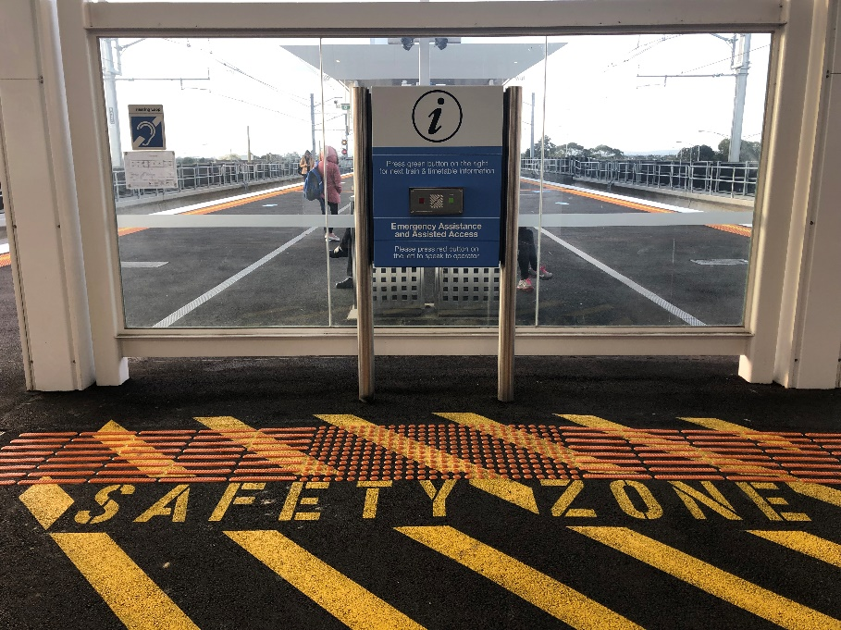
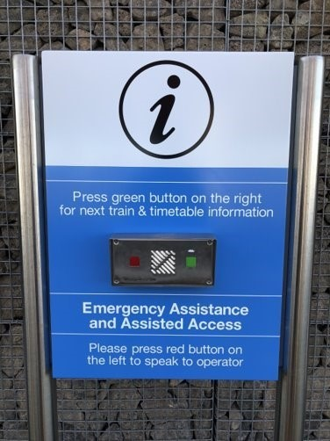
If you use a mobility device or are pushing a pram, wait parallel to the tracks and use your brakes.
For your safety and the safety of other passengers, please keep your speed to walking pace.

Dimensions, manoeuvrability and capacity considerations for mobility aids
Please consider the size of your mobility aid before you travel. Many boarding ramps are 800mm in width. If you’re choosing a new mobility aid, such as a wheelchair or scooter, it’s a good idea to check that it meets PTV’s specifications.

If you need additional time to board
Passengers who may need additional time to board are asked to board towards the front of the train where the driver is close by. Passengers with mobility aids will enter and exit at the first door of the first carriage. If you aren’t using a mobility aid, keep this area clear by using the second door of the train.

If you need boarding assistance
Wait for the train at the boarding point at the end of the platform in your direction of travel. As you enter most platforms, you will find a directional decal pointing to the boarding point (shown below).
The boarding point can be identified on most platforms by an International Symbol of Access decal (shown below).
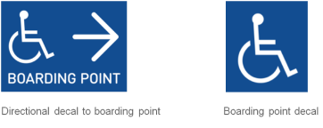
Please note trains can travel in different directions from the same platform. If you need boarding assistance and are unsure where to wait, please ask our station staff or press the red button on the left of the Customer Help Point to speak to staff.
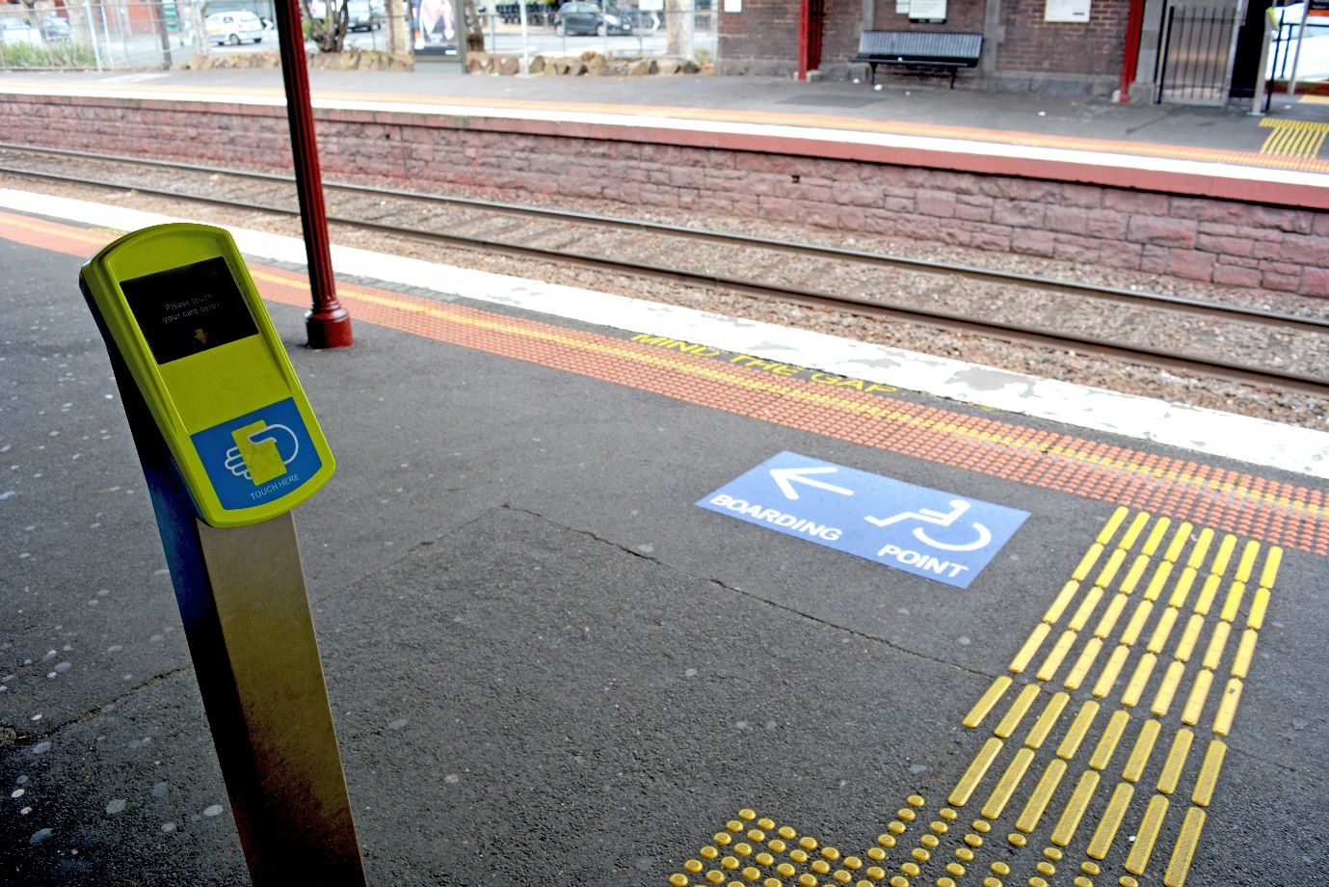
When the train arrives the driver or another staff member will approach and ask for your destination. The staff member will provide a portable ramp for you to board at the first door of the first carriage. If they are unable to board you at the first door, you will be assisted to board at an alternative door (which may vary depending on the type of train). Please listen to the instruction of the staff member.
If possible, please write down your destination on a note to provide to our staff, or when boarding tell them where you would like to disembark.
If interchanging or travelling across two lines, for example from Watergardens on the Sunbury line to Cheltenham on the Frankston line, tell the staff member where you wish to interchange, for example at Flinders Street Station. Metro staff will assist you off the train at your interchange point. Continue your journey or seek assistance from station staff, if needed.

Independent boarding
Some stations may have a raised boarding platform at the boarding point, or have higher platforms. These upgrades to the platform bridge the gap between the train and the platform to allow passengers to board independently. Drivers are still available to deploy a ramp if needed.
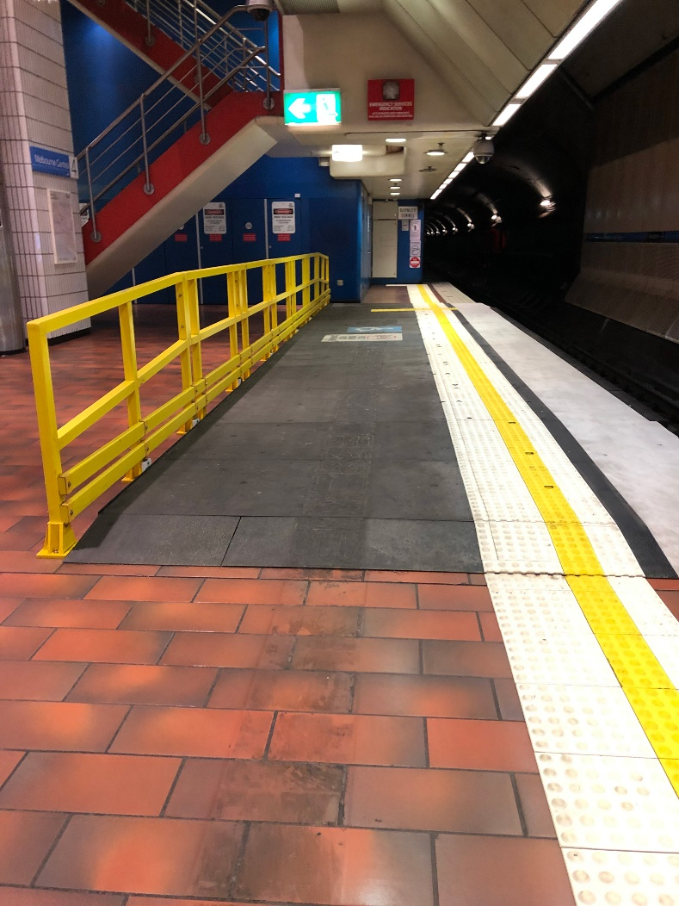

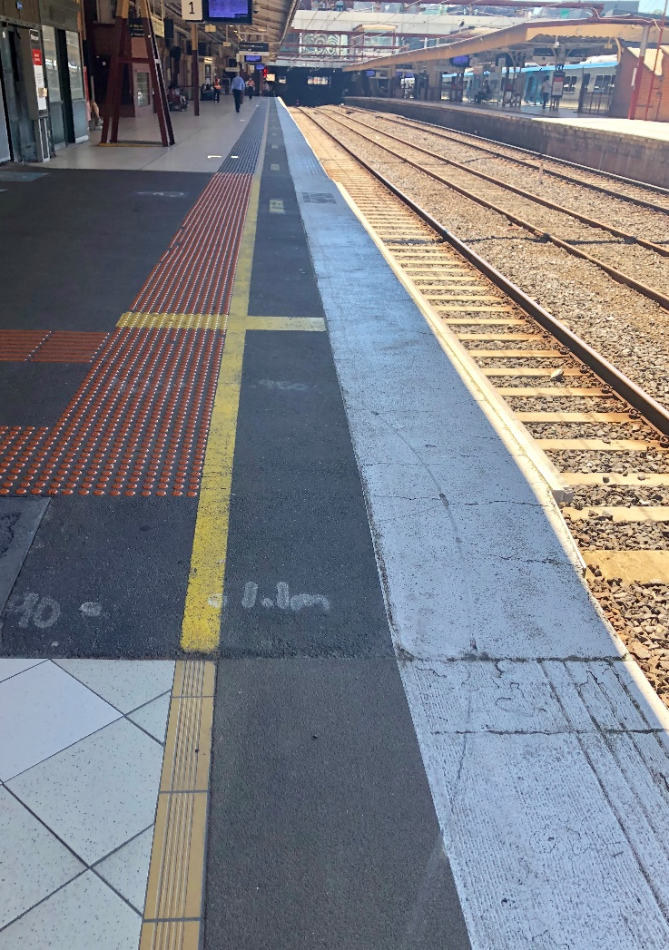

Stony Point Line
Metro operates diesel trains along the Stony Point line, which consists of ten stations from Frankston to Stony Point. Conductors are available to assist passengers onto and aboard trains on this line.

Companion Card
With a Companion Card, your carer or companion can travel free on trains when they travel with you. You're eligible for a Companion Card if you need assistance when travelling on public transport. The PTV website provides more information.

Low platforms
Metro’s Station Accessibility Guide lists stations with low platforms. At these locations, the boarding ramp from platform to train may be steeper than 1 in 8, and boarding assistance may be required. A list of these stations is below.
- Aircraft (in part - platform 1)
- Auburn
- Batman (in part - platform 1)
- Blackburn (in part - platforms 2 and 3)
- Brighton Beach (in part - platforms 2 and 3)
- Broadmeadows (in part - platform 2)
- Burnley (in part - platform 2)
- Darling (in part - platform 2)
- East Malvern (in part - platform 1)
- Essendon
- Flinders Street (in part - platform 7)
- Gardenvale (in part - platform 2)
- Glenferrie (in part - platform 1)
- Glen Iris (in part - platform 2)
- Glen Waverley (in part - platform 2)
- Gowrie (in part - platform 1)
- Hampton (in part - platform 1)
- Hawksburn
- Hawthorn (in part - platform 1)
- Heidelberg (in part - platform 2)
- Jewell (in part - platform 2)
- Kananook (in part - platform 2)
- Malvern (in part - platform 4)
- Middle Brighton
- Middle Footscray (in part - platform 2)
- Moonee Ponds (in part - platform 1)
- Mordialloc
- Newmarket (in part - platform 2)
- Newport
- North Brighton
- Oak Park (in part - platform 1)
- Prahran (in part - platform 1)
- Richmond
- Royal Park (in part - platform 2)
- Sandown Park (in part - platform 2)
- Spotswood (in part)
- Toorak
- Upwey
- Watsonia (in part - platform 1)
- West Richmond (in part - platform 2)
- Williamstown (in part - platform 1)
- Yarraman

