Metro Trains Melbourne

Customer Charter 2025 - 2026

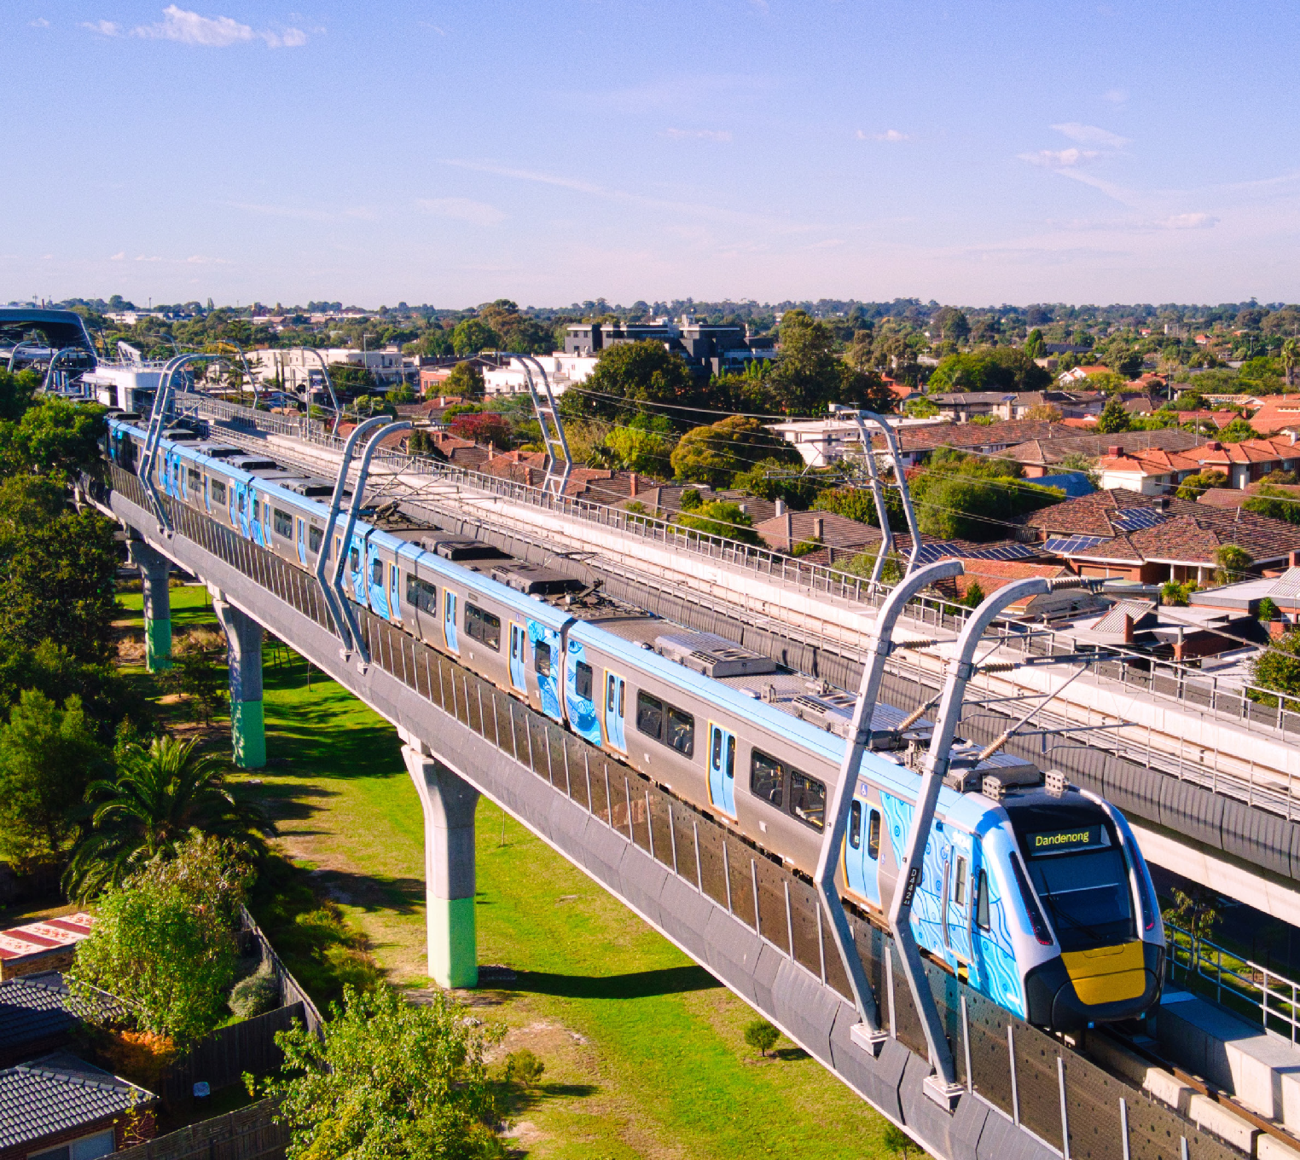

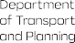
Authorised by the Victorian Government, 1 Treasury Place, Melbourne
transport.vic.gov.au


Get to know Metro Trains Melbourne

Up to 800,000 daily journeys
Nearly 1,000 kilometres of track

222 station

Operating Melbourne’s metropolitan train network is our privilege, and we commit to keeping Melbourne moving via:


Connected and reliable services

Safe and accessible services
Easy, accurate and personalised information

Engaging, skilled and approachable team members

Metro’s Customer Charter is our promise to you of how we will deliver on our commitments.


We commit to provide connected and reliable services:
We’re committed to providing a connected and reliable service for our passengers, that exceeds our performance targets.
If we don’t meet our performance targets, eligible passengers can request compensation.

2 Customer Charter 2025-2026
If we don’t run at least 98% of timetabled services each month or if less than 90% of these services are on time, customers are eligible for compensation.
We provide related information via:
metrotrains.com.au/metro-performance
Our network is always growing. This means new trains, new stations, line upgrades, cutting-edge technology and playing a key role in the ongoing Victorian Government’s Big Build.
We’re committed to excellent passenger experience and will minimise any unavoidable disruptions. To support us with network expansion and modernisation towards a world-class railway, disruptions are necessary. We’ll always go out of our way to minimise the impact to you and make the experience as pleasant and easy to navigate as possible.
More information on planned works: transport.vic.gov.au metrotrains.com.au/planned-works


We commit to provide safe and accessible services:
When you’re in our stations and trains, we monitor your safety with CCTV cameras. We work closely with Victoria Police and have Protective Service Officers (PSO) visible at stations and on services after 6PM and at 83 premium stations overnight on Fridays and Saturdays. Emergency help buttons are available on all carriages and most stations.
Abusive behaviour towards our passengers and team members is not tolerated.
We strive to keep our station precincts and trains clean from litter and graffiti. If you alert us to any areas that require attention, we’ll attend to those in a timely manner.
Our teams are trained and equipped to assist passengers with accessibility needs. Metro is accredited with the Communication Access Symbol, and our staff have received
specific training. This means our Station Staff, Authorised Officers and Drivers have the tools and strategies they need to support you if you need help communicating. Sunflower lanyards and wristbands were also provided free of charge for our passengers as part of our Hidden Disabilities Program.

To improve accessibility at our stations, in 2023 we introduced Language Badges for our staff who speak languages other than English.
Many of our stations have different features to support your journey. These include information screens, Assistance Animal Relief Areas at some premium stations, Wheelchair Movers, ramps, lifts and major station online virtual tours. If
you need assistance boarding, Station Staff can deploy a ramp between the platform and the train. Please let them know upon arrival at the station and they will assist you or alert the Driver.
More information on accessibility:
metrotrains.com.au/station-accessibility-features

We commit to provide easy, accurate, and personalised information:
We have many tools available to assist you in planning your journey. Sometimes we need to undertake essential maintenance, upgrade works, or unexpected events cause us to make changes to the services we provide.
We provide real-time information through:
- Station and on-board train announcements
- Information screens
- X (Twitter) @Metro Trains
- metroNotify App
- metrotrains.com.au
We work in partnership with Transport Victoria to provide real-time travel information, such as through Transport Victoria’s website and PTV app.

We commit to engage and enable our staff to do the best for you:

- Our people have all the training and information necessary to support our passengers should this be required.
- You can clearly identify our Station Staff and Authorised Officers through their Metro uniforms.
- At a number of our busiest stations, we have additional First Aid support on hand to help you when you need it most.
- More information on Stations facilities and hours: metrotrains.com.au


To help you and your fellow passengers have a safe and pleasant journey, please consider the following:
- Always travel with a valid ticket.
- Do not run at stations.
- Stand behind the yellow line on platforms.
- Hold the handrail on the escalators and keep to your left.
- Be mindful of other passengers - keep music and audio from mobile devices to a minimum, remove your backpack before boarding and take your rubbish with you.
- When travelling with a pram, board near the front of the train, keep a firm hold of your pram and apply the brakes when stationary at all times. Mind the gap and exit backwards when leaving the train.
- Don’t board with your bike at the first door of the first carriage. This is a priority area for mobility impaired passengers. Please make sure you keep doorways and passageways clear. Avoid travelling during peak hours and don’t enter busy carriages.
- Behaviours that make you or others feel threatened, frightened, or uncomfortable are never acceptable.
- Approach a Station Staff member if assistance is required, or at unstaffed stations press the red assistance button at Customer Help Points on the platform.
- All stations and trains are non-smoking/non-vaping areas.

Customer Charter 2025-2026 3

- Assistance animals can travel on our services.
- Dogs can travel on trains if they’re on a lead and remain on the floor. Other small animals can travel on trains in a suitable animal container.
- Only folding bikes can be brought onto replacement bus services – the Parkiteer secure bike parking at stations can be used to temporarily store bikes.
- Petrol powered skateboards and scooters are prohibited on all services.
- All trains are wheelchair accessible and have allocated spaces for passengers using mobility aids. Please keep accessible spaces free or made available on request.

 Helpful links and information Metro Trains Melbourne metrotrains.com.au

Transport Victoria
transport.vic.gov.au

Ticketing
transport.vic.gov.au/myki

Travellers Aid
travellersaid.org.au
Public Transport Ombudsman ptovic.com.au Inquiries@ptovic.com.au

Transport Victoria Contact Centre
1800 800 007
Sunday-Thursday: 6am-Midnight, Friday and Saturday: 24 hours

Interpreter Service
(03) 9321 5450

Lost Property
(03) 9610 7512
The Lost Property Office at Flinders Street Station outside the platform 1 gates is open between 8am to 5pm, Monday to Friday (except public holidays).

Trauma Support Service and metroNotify App

Trauma Support Service
1300 367 797
If you have been at the scene of a train incident as a passenger or pedestrian, or are affected as a family member, the Trauma Support Service is able to assist you.

metroNotify App
metrotrains.com.au/metronotify/
Available for iOS and Android
This app allows you to personalise Metro’s live service updates to receive the information you want at the times that you need it.

 We welcome your feedback Transport Victoria Contact Centre 1800 800 007
Sunday-Thursday: 6am-Midnight, Friday and Saturday: 24 hours
Please provide full contact details to enable our team to fully investigate your feedback.
If you are not satisfied with our response, you can escalate your feedback to Transport Victoria’s Customer Resolutions team, or the Public Transport Ombudsman, an independent office that investigates and provides fair, free and fast resolutions to public transport disputes.

4 Customer Charter 2025-2026

