Metro Trains Melbourne

Customer Charter
2026 - 2027

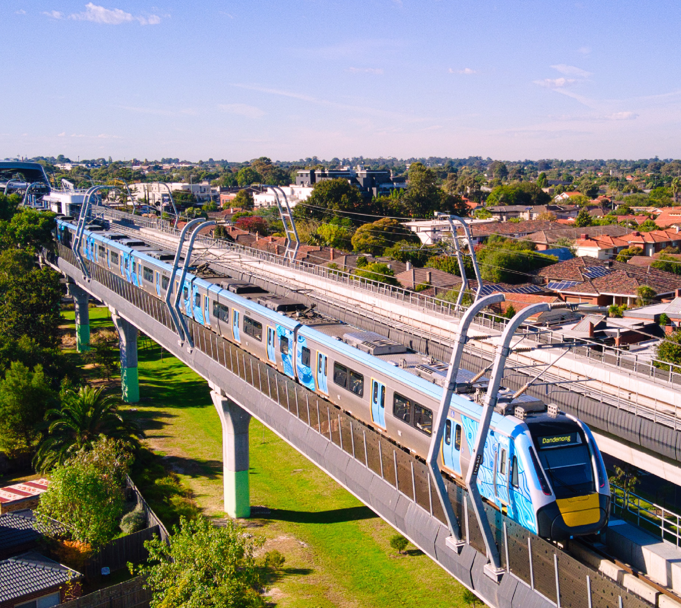

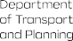
Authorised by the Victorian Government, 1 Treasury Place, Melbourne
transport.vic.gov.au


Get to know Metro Trains Melbourne

Over 2200 weekday services
Over 1,000 kilometres of track

227 stations

Operating Melbourne’s metropolitan train network is our privilege, and we commit to keeping Melbourne moving via:


Connected and reliable services

Safe and accessible services
Easy, accurate and personalised information

Engaging, skilled and approachable team members

Metro’s Customer Charter is our promise to you of how we will deliver on our commitments.


We commit to providing connected and reliable services:
We’re committed to providing a connected and reliable service for our passengers, that exceeds our performance targets.
If we don’t meet our performance targets, eligible passengers can request compensation.

2 Customer Charter 2026-2027
If we don’t run at least 98% of timetabled services each month or if less than 90% of these services are on time, customers are eligible for performance-based compensation.
We provide related information via:
metrotrains.com.au/metro-performance
Our network is always growing. This means new trains, new stations, line upgrades, cutting-edge technology and playing a key role in the ongoing Victorian Government’s Big Build.
We’re committed to excellent passenger experience and will minimise the impact of any unavoidable disruptions. To support us with network maintenance, expansion and modernisation towards a world-class railway, planned service disruptions are necessary. We’ll always go out of our way to minimise the impact to you and make the experience as pleasant and easy to navigate as possible.
More information on planned works: transport.vic.gov.au metrotrains.com.au/planned-works


We commit to providing safe and accessible services:
When you’re in our stations and trains, we monitor your safety with CCTV cameras. We work closely with Victoria Police and have roaming Protective Service Officers (PSOs) visible at stations and on services. Emergency help buttons are available on all carriages and most stations.
Abusive behaviour towards our passengers and team members is not tolerated.
We strive to keep our station precincts and trains clean from litter and graffiti. If you alert us to any areas that require attention, we’ll attend to those as a priority and in a timely manner.
Our teams are trained and equipped to assist passengers with accessibility needs. Metro is accredited with the Communication Access Symbol, and our staff have received specific training. This means our Station Staff, Authorised Officers and Drivers have the tools and strategies they need to support you if you need help communicating.
Sunflower lanyards and wristbands are available free of charge from Flinders Street Station and Southern Cross Station customer service windows as part of our Hidden Disabilities Program.

To improve accessibility at our stations, our staff who speak languages other than English can be identified by Language Badges.
Our stations have different features to support your journey. These include information screens, Assistance Animal Relief Areas at some premium stations, ramps, lifts and major station online virtual tours. If you need assistance boarding, go to the first carriage where Station Staff or a Driver will assist you. Press the Customer Help Point button if you are unsure.
More information on accessibility:
metrotrains.com.au/station-accessibility-features

The Community Connectors program operates at Frankston, Footscray and Dandenong Stations. Community Connectors are qualified community outreach workers who provide people in need with direct support and connect them to local support services.

We commit to providing easy, accurate, and personalised information:
We have many tools available to assist you in planning your journey. Sometimes we need to undertake essential maintenance, upgrade works, or unexpected events cause us to make changes to the services we provide.
We provide real-time information through:
- Station and on-board train announcements
- Passenger Information Displays
- X (Twitter) @Metro Trains
- metroNotify App
- metrotrains.com.au
We work in partnership with Transport Victoria to provide real-time travel information, such as through Transport Victoria’s website and PTV app.

We commit to engaging and enabling our staff to do the best for you:

- Our people have all the training and information necessary to support our passengers should this be required.
- You can clearly identify our Station Staff and Authorised Officers through their Metro uniforms.
- At a number of our busiest stations, we have additional First Aid support.
- More information on Stations facilities and staffing hours: metrotrains.com.au


To help you and your fellow passengers have a safe and pleasant journey, please consider the following:
- Always travel with a valid ticket.
- Do not run at stations.
- Stand behind the yellow line on platforms.
- Hold the handrail on the escalators and keep to your left.
- Be mindful of other passengers - keep music and audio from mobile devices to a minimum, remove your backpack before boarding and take your rubbish with you.
- When travelling with a pram, board near the front of the train, keep a firm hold of your pram and apply the brakes when stationary at all times. Mind the gap and exit backwards when leaving the train.
- Do not attempt to enter or exit a train when doors are closing.
- Don’t board with your bike at the first door of the first carriage. This is a priority area for passengers with mobility aids. Please make sure you keep doorways and passageways clear. Avoid travelling during peak hours and don’t enter busy carriages.
- Behaviours that make you or others feel threatened, frightened, or uncomfortable are never acceptable.
- Approach a Station Staff member if assistance is required, or at unstaffed stations press the red assistance button at Customer Help Points on the platform.
- All stations and trains are non-smoking/non-vaping areas.

Customer Charter 2026-2027 3

- Assistance animals can travel on our services.
- Dogs can travel on trains if they’re on a lead, muzzled and remain on the floor. Other small animals can travel on trains in a suitable animal container.
- Only folding bikes can be brought onto replacement bus services – the Parkiteer secure bike parking at stations can be used to temporarily store bikes.
- Petrol powered skateboards, scooters and converted
e-bikes are prohibited at the station and on all services.
- All trains are wheelchair accessible and have allocated spaces for passengers using mobility aids. Please keep accessible spaces free or made available on request.
- Offer your seat if you think someone else might need it more and look out for passengers displaying the Sunflower symbol, this means they have a disability that isn’t visible.

 Helpful links and information Metro Trains Melbourne
metrotrains.com.au

Transport Victoria
transport.vic.gov.au

Ticketing
transport.vic.gov.au/tickets-and-payments

Travellers Aid
travellersaid.org.au
Public Transport Ombudsman
ptovic.com.au
enquiries@ptovic.com.au

Transport Victoria Contact Centre
1800 800 007
Sunday-Thursday: 6am-Midnight, Friday and Saturday: 24 hours

Interpreter Service
(03) 9321 5450

Lost Property
(03) 9610 7512
The Lost Property Office at Flinders Street Station outside the platform 1 gates is open between 8am to 5pm, Monday to Friday (except public holidays).

Trauma Support Service and metroNotify App

Trauma Support Service
1300 367 797
If you have been at the scene of a train incident as a passenger or pedestrian, or are affected as a family member, the Trauma Support Service is able to assist you.

metroNotify App
metrotrains.com.au/metronotify/
Available for iOS and Android
This app allows you to personalise Metro’s live service updates to receive the information you want at the times that you need it.

 We welcome your feedback Transport Victoria Contact Centre
1800 800 007
Sunday-Thursday: 6am-Midnight, Friday and Saturday: 24 hours
Please provide full contact details to enable our team to fully investigate your feedback.
If you are not satisfied with our response, you can escalate your feedback to Transport Victoria’s Customer Resolutions team, or the Public Transport Ombudsman, an independent office that investigates and provides fair, free and fast resolutions to public transport disputes.

4 Customer Charter 2026-2027

